Experiment Number : 04 Date:

ARRAYS
Aim:
To understand and implement array operations in Java.
PRE LAB EXERCISE
QUESTIONS
- What is an array?
An array is a collection of elements of the same data type stored in contiguous memory locations and accessed using a single variable name with an index.
Example:
int[] arr = {10, 20, 30};

- Why are arrays used?
Arrays are used to:
- Store multiple values of the same type in one variable
- Reduce the need for many separate variables
- Make data easy to manage and process using loops
- Improve program readability and efficiency

- What is the difference between array and variable?
Variable | Array
Stores one value | Stores multiple values
Needs separate variables for each value | Uses one name for many values
Cannot be indexed | Accessed using index
Example: int x = 10; | Example: int[] a = {10, 20, 30};

IN LAB EXERCISE
Objective:
To perform array operations using simple programs.
PROGRAMS:
1. Program to Read and Print Array Elements
Code:
import java.util.Scanner;
public class ReadPrintArray {
public static void main(String[] args) {
Scanner sc = new Scanner(System.in);
int[] arr = new int[5];
System.out.println("Enter 5 elements:");
for(int i = 0; i < 5; i++)
arr[i] = sc.nextInt();
System.out.println("Array elements are:");
for(int i = 0; i < 5; i++)
System.out.print(arr[i] + " ");
}
}
OUTPUT:
Input:
10 20 30 40 50
Output:
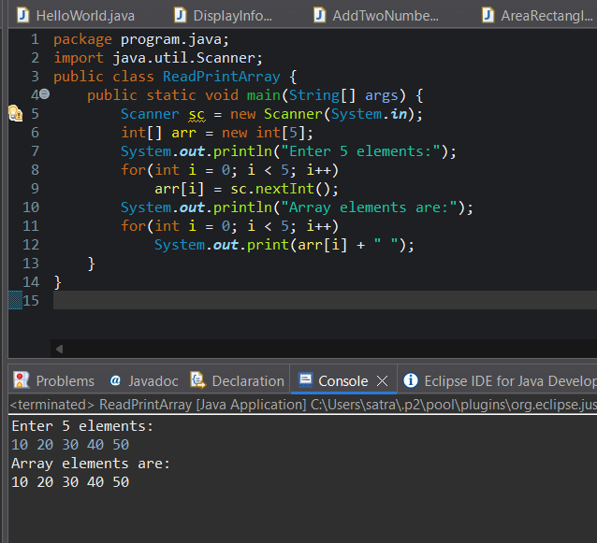
Array elements are:
10 20 30 40 50

2. Program to Find Sum of Array Elements
Code:
import java.util.Scanner;
public class SumArray {
public static void main(String[] args) {
Scanner sc = new Scanner(System.in);
int[] arr = new int[5];
int sum = 0;
System.out.println("Enter 5 elements:");
for(int i = 0; i < 5; i++)
arr[i] = sc.nextInt();
for(int i = 0; i < 5; i++)
sum += arr[i];
System.out.println("Sum = " + sum);
}
}
OUTPUT:
Input:
5 10 15 20 25
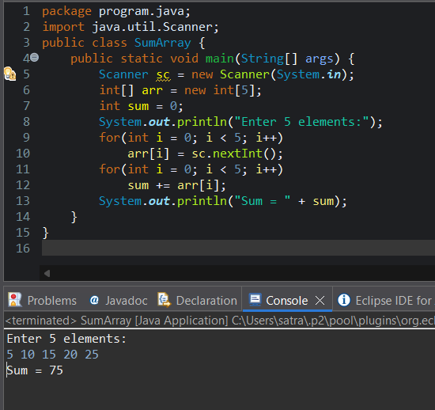
Output:
Sum = 75

3. Program to Find Largest Element in an Array
Code:
import java.util.Scanner;
public class LargestElement {
public static void main(String[] args) {
Scanner sc = new Scanner(System.in);
int[] arr = new int[5];
System.out.println("Enter 5 elements:");
for(int i = 0; i < 5; i++)
arr[i] = sc.nextInt();
int max = arr[0];
for(int i = 1; i < 5; i++)
if(arr[i] > max)
max = arr[i];
System.out.println("Largest element = " + max);
}
}
OUTPUT:
Input:
12 45 23 9 30
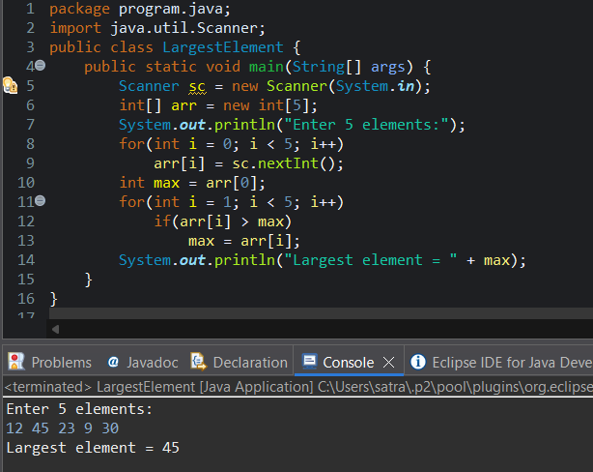
Output:
Largest element = 45

4. Program to Reverse an Array
Code:
import java.util.Scanner;

public class ReverseArray {
public static void main(String[] args) {
Scanner sc = new Scanner(System.in);
int[] arr = new int[5];
System.out.println("Enter 5 elements:");
for(int i = 0; i < 5; i++)
arr[i] = sc.nextInt();
System.out.println("Reversed array:");
for(int i = 4; i >= 0; i--)
System.out.print(arr[i] + " ");
}
}
OUTPUT:
Input:
1 2 3 4 5
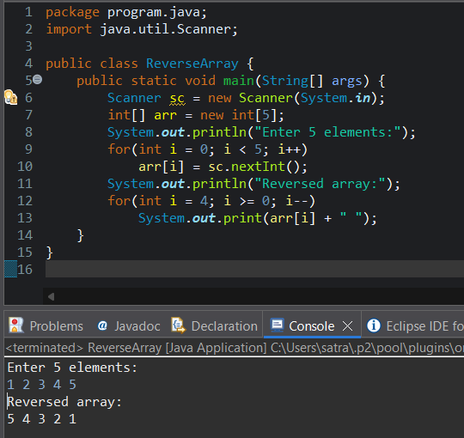
Output:
Reversed array:
5 4 3 2 1

5. Program to Count Even and Odd Numbers
Code:
import java.util.Scanner;
public class EvenOddCount {
public static void main(String[] args) {
Scanner sc = new Scanner(System.in);
int[] arr = new int[5];
int even = 0, odd = 0;
System.out.println("Enter 5 elements:");
for(int i = 0; i < 5; i++)
arr[i] = sc.nextInt();
for(int i = 0; i < 5; i++) {
if(arr[i] % 2 == 0)
even++;
else
odd++;
}

System.out.println("Even = " + even);
System.out.println("Odd = " + odd);
}
}
OUTPUT:
Input:
2 7 4 9 10
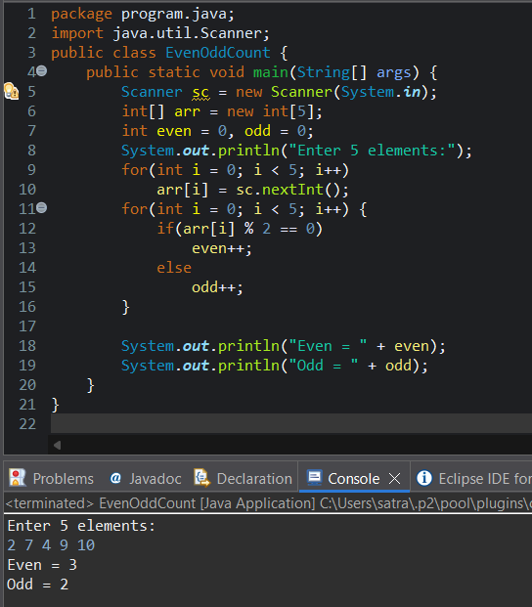
Output:
Even = 3
Odd = 2

6. Program to Sort Array in Ascending Order
Code:
import java.util.Scanner;
public class SortArray {
public static void main(String[] args) {
Scanner sc = new Scanner(System.in);
int[] arr = new int[5];
int temp;
System.out.println("Enter 5 elements:");
for(int i = 0; i < 5; i++)
arr[i] = sc.nextInt();
for(int i = 0; i < 5; i++) {
for(int j = i + 1; j < 5; j++) {
if(arr[i] > arr[j]) {
temp = arr[i];
arr[i] = arr[j];
arr[j] = temp;
}
}
}
System.out.println("Sorted array:");
for(int i = 0; i < 5; i++)
System.out.print(arr[i] + " ");
}
}
OUTPUT:
Input:
45 12 78 23 9
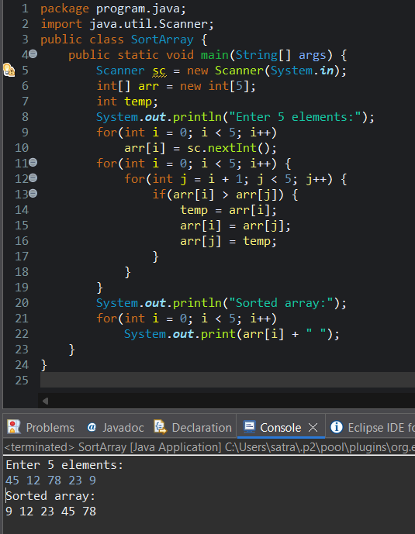
Output:
Sorted array:
9 12 23 45 78

7. Program to Find Second Largest Element
Code:
import java.util.Scanner;
public class SecondLargest {
public static void main(String[] args) {
Scanner sc = new Scanner(System.in);
int[] arr = new int[5];

System.out.println("Enter 5 elements:");
for(int i = 0; i < 5; i++)
arr[i] = sc.nextInt();
int largest = arr[0];
int second = arr[0];
for(int i = 0; i < 5; i++) {
if(arr[i] > largest) {
second = largest;
largest = arr[i];
}
}
System.out.println("Second largest = " + second);
}
}
OUTPUT:
Input:
10 45 23 89 67
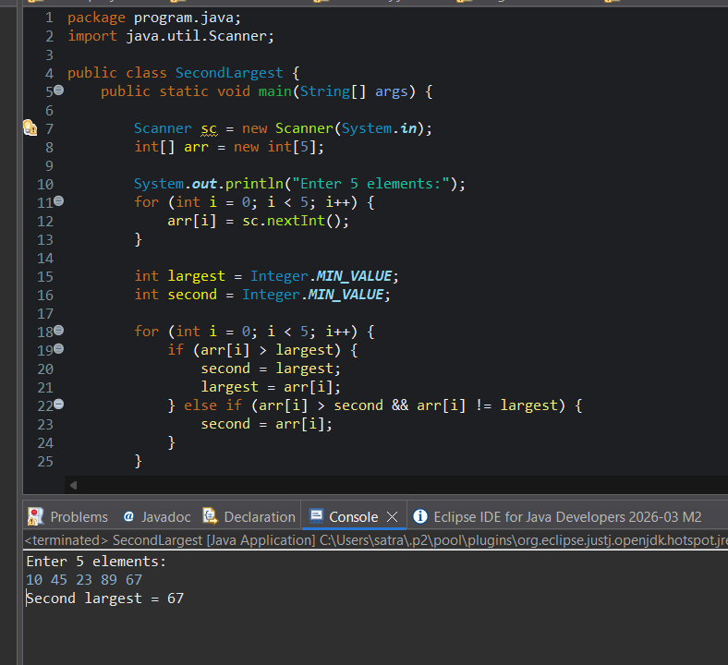
Output:
Second largest = 67

8. Program for Matrix Addition (2D Array)
Code:
import java.util.Scanner;
public class MatrixAddition {
public static void main(String[] args) {
Scanner sc = new Scanner(System.in);
int[][] a = new int[2][2];
int[][] b = new int[2][2];
int[][] sum = new int[2][2];
System.out.println("Enter elements of matrix A:");
for(int i = 0; i < 2; i++)
for(int j = 0; j < 2; j++)
a[i][j] = sc.nextInt();
System.out.println("Enter elements of matrix B:");
for(int i = 0; i < 2; i++)
for(int j = 0; j < 2; j++)
b[i][j] = sc.nextInt();
for(int i = 0; i < 2; i++)
for(int j = 0; j < 2; j++)
sum[i][j] = a[i][j] + b[i][j];
System.out.println("Sum matrix:");
for(int i = 0; i < 2; i++) {
for(int j = 0; j < 2; j++)
System.out.print(sum[i][j] + " ");
System.out.println();
}
}
}
OUTPUT:
Matrix A:
1 2
3 4
Matrix B:
5 6
7 8
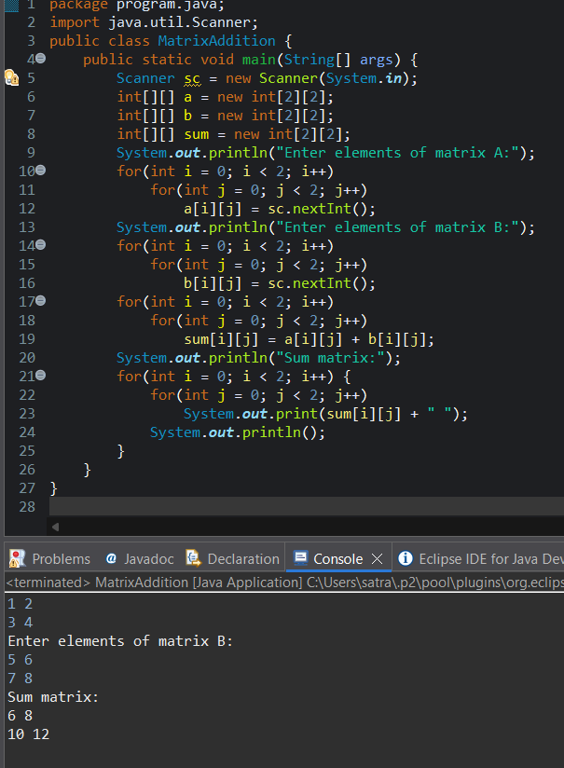
Sum matrix:
6 8
10 12

POST LAB EXERCISE
- Why is array indexing usually started from zero instead of one?
Array indexing starts from zero because the index represents the offset from the starting memory location.
The first element is stored at the base address, so its offset is 0.
- What happens if we try to access an array element outside its declared size?
Accessing an array element outside its declared size causes a runtime error.
In Java, it throws an ArrayIndexOutOfBoundsException and the program terminates.

- How does memory allocation differ for static arrays and dynamic arrays?
Static Array | Dynamic Array
Size is fixed at compile time | Size can be decided at runtime
Memory allocated once | Memory allocated during execution
Faster access | Slightly slower due to resizing
Example: int a[5]; | Example: ArrayList<Integer>

- Why is searching faster in arrays compared to linked lists?
Searching is faster in arrays because:
- Elements are stored in contiguous memory
- Direct access is possible using index
Linked lists require sequential traversal, which is slower.

- What is the difference between contiguous and non-contiguous memory allocation?
Contiguous Memory | Non-Contiguous Memory
Memory blocks are placed next to each other | Memory blocks are scattered
Faster access | Slower access
Used by arrays | Used by linked lists
Less flexible | More flexible

Result:

Thus the array operations were executed successfully.

ASSESSMENT

Description | Max Marks | Marks Awarded
Pre Lab Exercise | 5
In Lab Exercise | 10
Post Lab Exercise | 5
Viva | 10
Total | 30
Faculty Signature

